IST 263

Activity week 08

SETUP
Create a folder in your GitHub repository called lab08. Download the document participation08.html from Blackboard into that folder.

CSS styling
- Open participation08.html in VS Code.
- We will be adding our CSS code to the head of the document, inside the <style> tag.
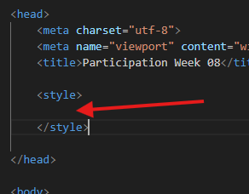
- Style the body tag – font-family: Verdana, Geneva, Tahoma, sans-serif
- Style your h1 and h2 tags with the color #3d1866
- Create a class called .paragraph1 and give it the background-color #F76900 and color #FFFFFF
- Create a class called .paragraph2 and give it the background-color #000E54 and color #FFFFFF
- Create a class called .paragraph3 and give it the background-color #ADB3B8 and color #000E54
- Add padding to each of the three paragraph classes of 2em.
- Within the body of the html document, add class=”paragraph1” to the first paragraph.
- Add class paragraph2 to the second paragraph and paragraph3 to the third paragraph.
- Save the file and commit your file using GitHub Desktop.
- Validate your file through https://validator.nu and fix any errors.

What will You hand IN?
Create a word document, pdf or use the "write submission" option in Blackboard to provide the following:
- Submit the URL for the participation08.html to Participation 8 in Blackboard.
FYI, this is what the finished product should look like.
